**Unit 4 Graded Exercise 1**

The following questions come from the “Check your understanding” examples of Chapter 13 in your textbook.

After you are finished, please submit a Microsoft Word file that contains your answers. In this case, since the assignments are “by hand,” you don’t have to run these in Oracle. Your document should be named **U4_GradedExercise1_Lastname.docx**.

(13-3) Question 1:

Do these joins by hand, without a computer. Join a row of Table 1 with a row of Table 2 if the first letters are the same. Show all the rows of both tables, even if they do not have a matching row in the other table. Create the result table and state if this is a one-to-one relationship in the mathematical sense or in the database design sense.

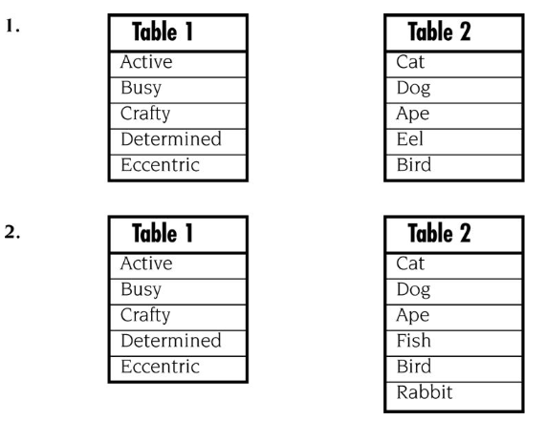

(13-4) Question 2:

Do this join by hand, without a computer. Join a row of Table 1 with a row of Table 2 if the first letters are the same. Create the result table and state if this is a many-to-one relationship.

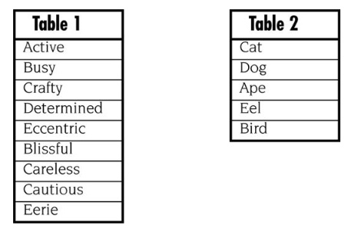

(13-5) Question 3:

Do this join by hand, without a computer. Join a row of Table 1 with a row of Table 2 if the first letters are the same. Create the result table and state if this is a one-to-many relationship.

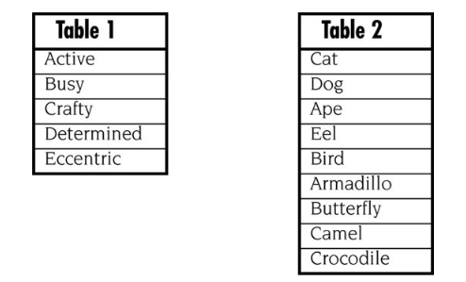

(13-6) Question 4:

Do this join by hand, without a computer. Join a row of Table 1 with a row of Table 2 if the first letters are the same. Create the result table and state if this is a many-to-many relationship.

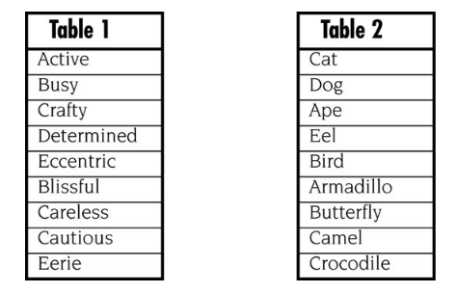

(13-8) Question 5:

Which rows from each table are unmatched and would be dropped from the inner join? Assume a row of Table 1 would be joined with a row of Table 2 if the first letters are the same.

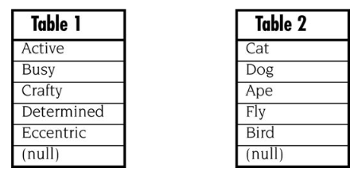

(13-9) Question 6:

Write a *select* statement to create the inner join of these tables. Join a row of Table 1 with a row of Table 2 if the first letters are the same. Write the SQL in the recommended way, using variation 1.

